# Bollinger band EA version 1.06

**Rules (strategy, entry, exit)**

Main rules:

1. EA opens a trade
   1. sell, if price touches upperBB //mean-reversal strategy
   2. buy, if price touches lowerBB
2. (if useHedge=ON, open at the same time a hedge trade (in opposite direction))  
   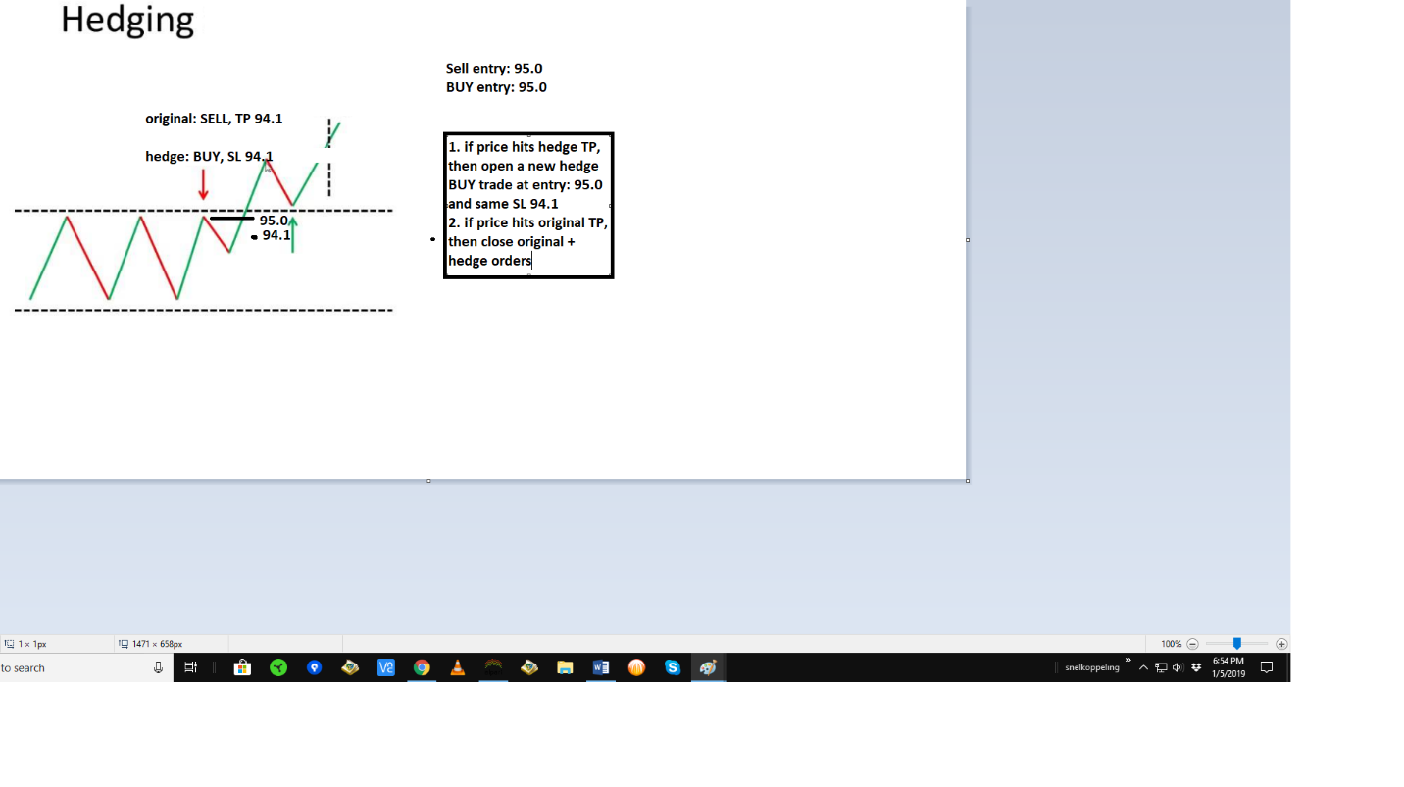 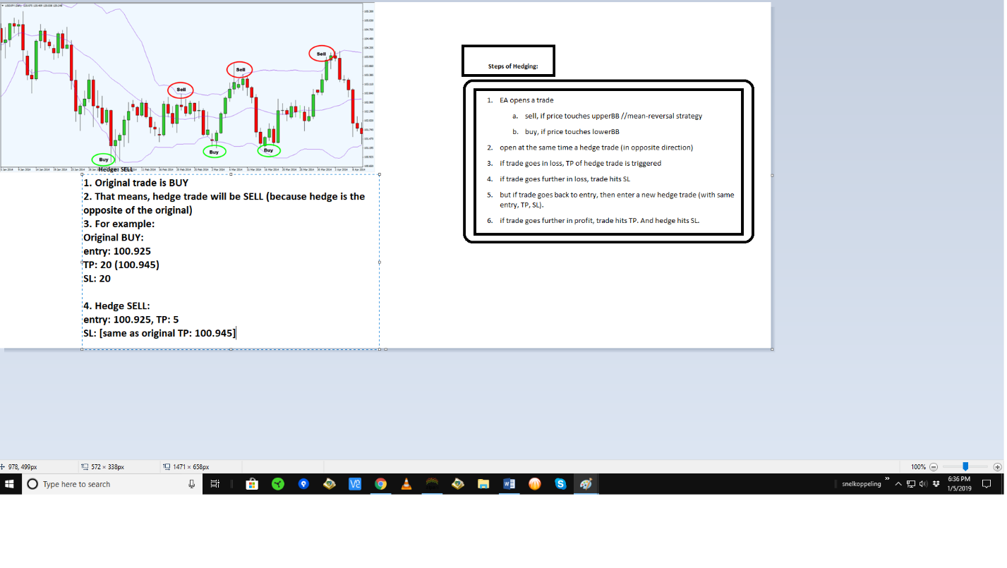
3. if trade goes in loss, TP of hedge trade is triggered
4. if trade goes further in loss, trade hits SL
5. but if trade goes back to entry, then enter a new hedge trade (with same entry, TP, SL).
6. if trade goes further in profit, trade hits TP. And hedge hits SL.

Misc rules:

* EA is fully automated
* all orders are instant orders
* only 1 order is open at a time
* only open an order, if spread<0.5 pips
* only exit an order, if spread<0.5 pips

**EA parameters**

Trade management

* on/off: EAisAlwaysOn =on (default)
* lotsize: 0.02
* TP_SL_method: [fixed, fixed upperband to centerband, fixed upperband to lowerband, dynamic from upperband to centerband, dynamic from upperband to lowerband]
* TP:
  + fixed: [20] pips
  + fixed: from upperband to centerband/lowerband //use fixed TP at entry. RR: 1:1
  + dynamic: from upperband to centerband/lowerband //use dynamic TP as bands widen. RR: 1:1
  + last High/Low, that is minimum [20] pips from entry and max [50] pips  
    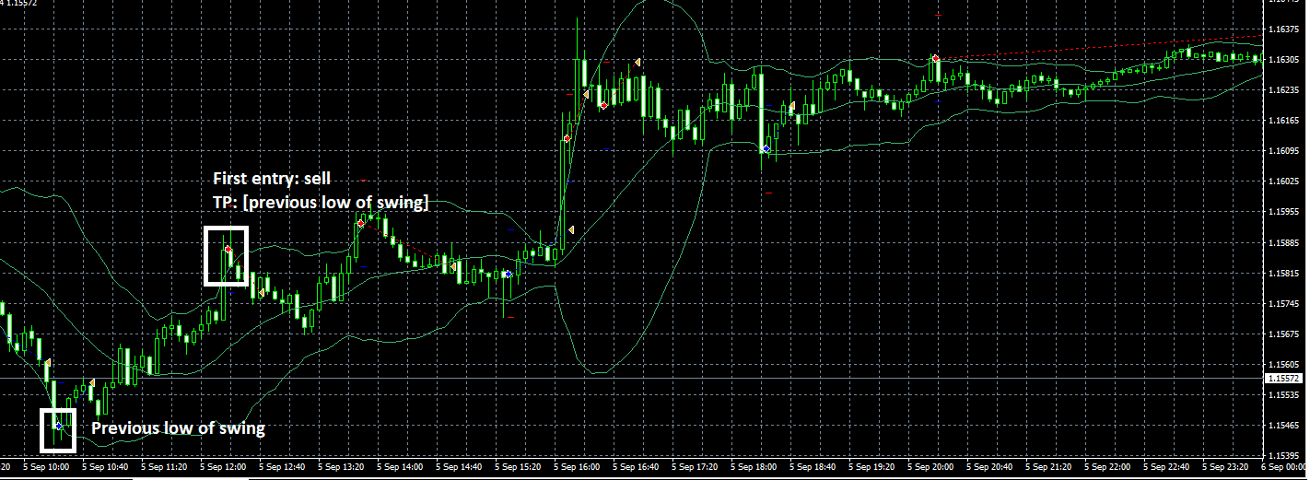
* SL:
  + fixed: [20] pips
  + fixed: from upperband to centerband/lowerband //use fixed TP at entry. RR: 1:1
  + dynamic: from upperband to centerband/lowerband //use dynamic TP as bands widen. RR: 1:1
  + last High/Low, that is minimum [20] pips from entry and max [50] pips && SL<=TP

Hedge trade

* + useHedge: on/off
  + resetHedgeAfterTP: on/off //on means, if hedge_TP is hit, then set a new hedge trade (with exact same entry, SL and TP) //new hedge trade is pending order //delete pending order, if original trade hits SL.
  + lotsize hedge: 0.01
  + hedge_TP_method: [fixed, fixed centerband, dynamic centerband]
  + hedge TP_fixed: [10] pips
  + hedge_SL: //this is the same price as original_trade_TP //so, if original trade hits TP, then exit the Hedge trade in loss.

Trade direction

* on/off: changeBuytoSell. //this means, buy = sell and sell = buy //momentum strategy
* TradeLong=true
* TradeShort=true
* on/off: if SL is hit, then next trade will be in the [opposite, same] direction

Martingale

* useMartingale: on/off //on means, every new trade gets more lotsize until TP is hit
* maxOrders: [9] //this means, after 9 losses, the EA starts from 0.01 lotsize for the next trade.
* lotsizeMethod: [fixed, add, multiply] //add= lotsize + lotsize. //multiply= lotsize x lotsize
* lotsizeStep: [0.03]
  + example:
  + //add = order 1: 0.03 lot, order 2: 0.06, order 3: 0.09 lot
  + //multiply = order 1: 0.03 lot, order 2: 0.09, order 3: 0.27 lot
* resetMethod: [fast, slow]
  + example
  + //fast means, if a trade hits TP, then reset lotsize to 0.01 for the next trade.
  + //slow means, if a trade hits TP, then decrease lotsize for the next trade. For example, order 1 was 0.03, order 2 was 0.06, order 3 was 0.09. If order 3 hits TP, then the next order decreases lotsize to 0.06 (which is the lotsize of previous trade)

Timezone

* Monday on/off
* Tuesday on/off
* Wednesday on/off
* Thursday on/off
* Friday on/off
* London session
  + useLOsession=true
  + start [7]AM gmt
  + end [13]PM
* NY session
  + useNYsession=true
  + start [14]PM
  + end [20]PM
* Night session
  + useNightsession=true
  + start [21]PM
  + end [6]AM

Misc

* skip: [2] //skip means, EA skips 2 consecutive losses (virtually) and afterwards the EA opens a real trade. So, the EA waits for 2 virtual consecutive losses.
* checkPriceEveryTick=false //false means, check price every new candle
* Magicnumber: 123456
* TradeComment: bollinger_band_1.00
* Slippage: 5

**Filters (indicators, price action)**

Indicators: general

* useIndicators: on/off
* each indicator gets the parameter:
  + all parameters have on/off
  + basic indicator parameters (use default parameter settings)
  + lookback_candles: [10] candles
  + lookback_pips: [5] pip //this means, entry is within [5] pips from indicator_filter

Indicators: indicator settings

* (Bollinger) band
  + only open a new trade, if price closed above outerband directly from ‘centerband'
  + entryMethod: [if price touched outerband, if price closed outside outerband, if price crossed outerband and the first opposite candle is closed, if price crossed ‘above’ outerband and returns ‘below’ outerband]
  + //entryMethod #1: if price touched outerband
  + //entryMethod #2: if price closed outside outerband
    - entryPipsFromOuterband: [5] //entry is 5 pips above upperband or below lowerband
    - entryAfterNumberOfCandles: [1] //if candle closed above upperBB, then wait for [1] other bullish candle to close and then open a trade.
  + //entryMethod #3: if price crossed outerband and the first opposite candle is closed
    - //this entryMethod means, for example: price crossed upperband and is followed by 6 bullish candles. Then, sell, if a bearish candle closed.
  + //entryMethod #4: if price crossed ‘above’ outerband and returns ‘below’ outerband
    - maxPips: [5] pips //if candle closes (from outside outerband to inside outerband), then only open a trade if entry is maximum [5] pips from outerband.
  + only open a trade, if (HIGHBB-LOWBB)<= [20] pips //momentum strategy
  + only open a trade, if (HIGHBB-LOWBB)>= [50] pips //mean-reversal strategy
  + only open a buy trade, if centerband slopes [upwards, downwards]
    - slope degree <=[40] degrees //mean-reversal strategy
    - slope degree >=[20] degrees //momentrum strategy
      * for at least [6] candles
      * for at least [3] swings
  + only open a sell trade, if centerband slopes [upwards, downwards]
    - the same as above
  + only open a trade, if price came from centerband.
  + only sell, if price came from [upperband, lowerband]
  + only buy, if price came from [upperband, lowerband]
  + don’t open a trade, if [3] and more candles ago price was [5] pips below the upperband (or [5] pips above the lowerband)
  + don’t open a trade, if between [4] and [10] candles ago price touched the outerband
* squeeze indicators
  + only open a trade, if squeeze<[10]
  + only open a trade, if squeeze>[50]
* arrow indicators
  + only buy, if arrow is up
  + only sell, if arrow is down
* atr/adr
  + open a trade in the direction of candle_open, if ATR>ADR
  + open a trade in the opposite direction of candle_open, if ATR<ADR
  + ATR
    - [buy], if previous down swing has a bearish ATR swing
    - [sell], if previous up swing has a bearish ATR swing  
      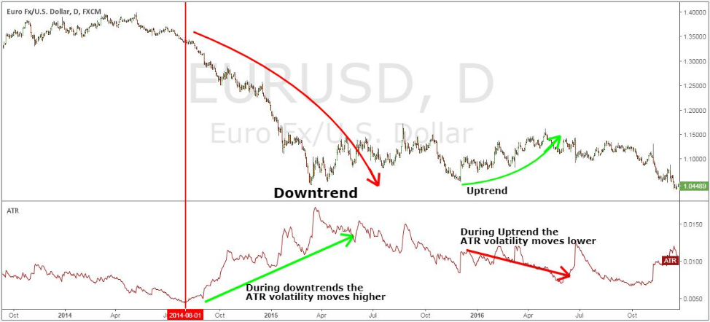
    - only open trade, if ATR breaks above 20EMA //for momentum strategy  
      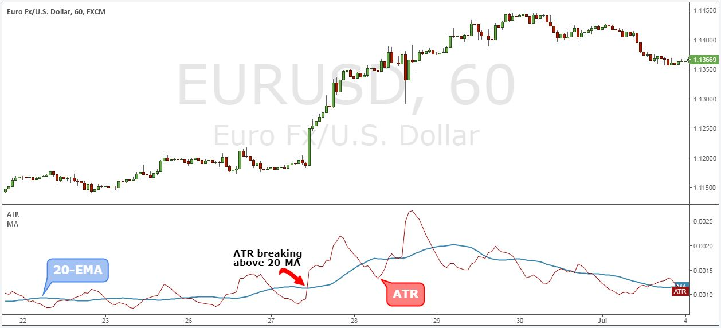  
      source: <https://tradingstrategyguides.com/best-average-true-range-forex/>
    - parameter: on/off. If ATR increases, then increase TP/SL (use same ratio as ATR)
    - ATRmacd_OsWAD(trueforex.pp.ua).mq4:
      * only open a trade, if color changes from light green to dark green //momentum strategy
      * only open a trade, if color changes from dark red to light red  
        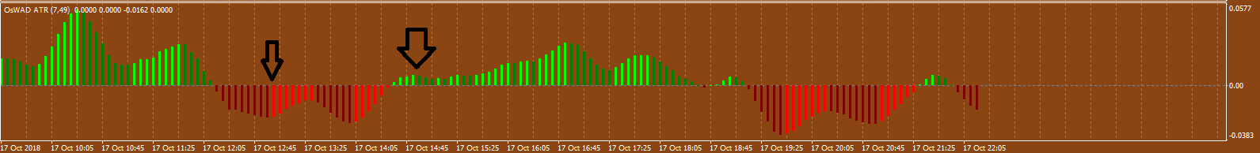
* candle length indicator
  + only open a trade, if candle length>[10] pips
* wick indicator
  + only open a trade, if candle wick>[5] pips
  + sell for [bullish] wick
  + buy for [bearish] wick
* gap finder
  + only open a trade in direction of previous gap
  + gap is at least [10] pip. Lookback is [50] pips.
* single moving average
  + only open a trade, in direction of MA
  + buy, if price is above MA
  + sell, if price is below MA
* crossover moving average
  + only open a trade, in direction of crossover. Lookback is [10] candles
* oscillator
  + sell if overbought //mean-reversal strategy
  + buy if oversold
  + only sell, if price[1]>overbought, price[0]<overbought //this means, sell, if previous candle was inside overbought zone and now closed below this zone.
  + skip [1] //skip the first time that price crosses below overbought, and open a trade if price goes above and then goes below overbought again (for the second time)
* pivot point
  + only sell, if price goes upwards and touches pivot point
  + only buy, if price goes downwards and touches pivot point
  + only use [S1,R1][S2,R2][S3,R3]
* volume indicator
  + only open a trade, if volume is above [50] //momentum strategy
  + only open a trade, if volume is below [50] //mean-reversal strategy
* zigzag indicator
  + only sell, if down swing is bigger than previous up swing
  + only buy, if up swing is bigger than previous down swing
* candlestick indicator
  + only open a trade, if doji
  + only open a trade, if bullish/bearish engulving pattern
* volume
  + only open a trade, if volume <= [10] //mean-reversal strategy
  + only open a trade, if volume >= [50] //momentum strategy

Price action:

* usePriceAction: on/off
* wick
  + don't open a trade, if **candle wick** (of previous candle) outside of outerband, is longer than [10] pips
  + trading conditions: only open trade, if **candle wick** (of previous candle) outside of outerband, is less than [5] pips
* re-test
  + only buy if sell failed the re-test
* big swing
  + skip [200] pips //this means, wait for a 200 pip swing, and then start trading
  + only open a trade, if previous [200] pips did not have a 50% retracement
    - lookback: [20] candles
    - method: [only for candle close OR only from high of swing until low of swing] //the last option means: all candles between ‘swing high and low’.
* swings
  + only open a trade, if previous two swings were [HH][LL][HL][LH]
  + only open a buy trade, if price previously touched [lowerband, upperband]
  + only open a sell trade, if price previously touched [lowerband, upperband]
* candles
  + only open a trade, if [6] consecutive bullish/bearish candles
  + exit trade in profit, if trade goes immediately [5] pips in profit without going [2] pips in loss
  + breakeven, if trade goes immediately [5] pips in profit without going [2] pips in loss
* double top/bottom
  + only open a trade, if double top or double bottom
    - lookback:[50] candles
  + only open a trade, if candle wick crosses the double top/bottom.
    - candleWick_pips=[5] //this means, only open a trade, if candle wick is at least 5 pips and breaks out the double top/bottom  
      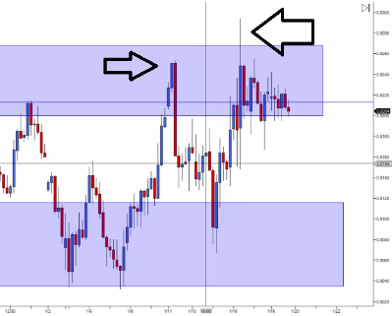
* round number
  + only open a trade, if round number
    - entryFromRoundNumber_pips=[5] pips //this means, entry is within [5] pips from the round number
    - roundNumber_pips=[100] //this means, each round number differs 100 pips
      * example:
      * //EURUSD price: 1.1500, 1.1600, 1.1700, 1.1800, 1.1900, 1.2000 etc

Update:

* 2 options:
  + every indicator will be analysed based on
    - the last candle condition (the moment when the trade closes (tp/sl)
    - the moment of trade entry. (eg. at entry 9am the 200MA is at price 101.00, and closing condition 10am, price is at 102.00., same with upperband in BB)
  + indicator lookback
  + visual counters